­­



Submitted to:

Sir MohibUllah

***BS-Software Engineering 5th-E***

Title: Assignment 1

CCN

Hamza Mehmood

Roll# SP-21-110

NUML-S21-23530



National University of Modern Languages

**Question # 01:**

1.Create GUI based Calculator with Separate Class for Calculation process

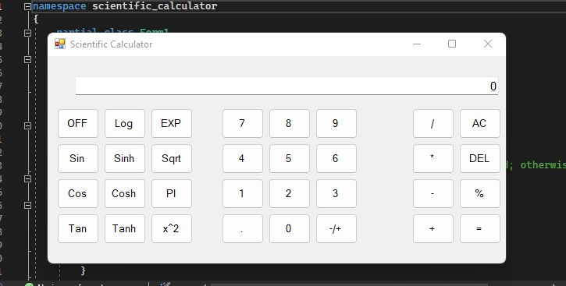

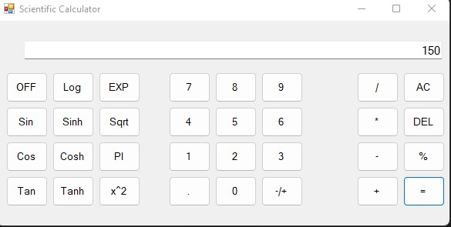

**Question # 02:**

2. Create Tic tac toe game.

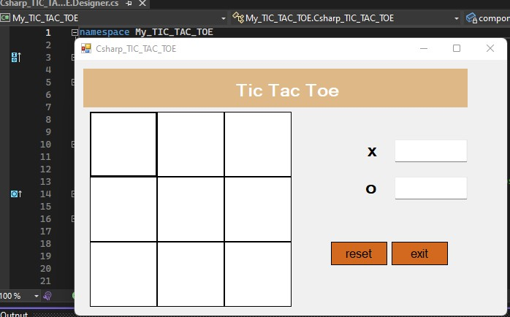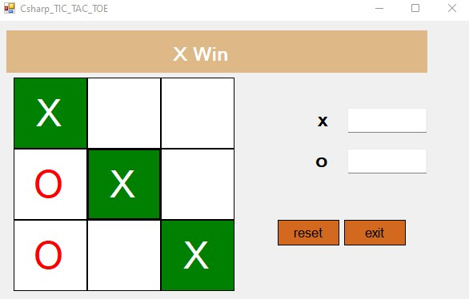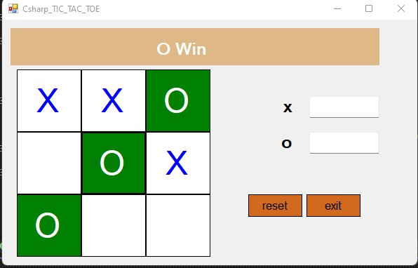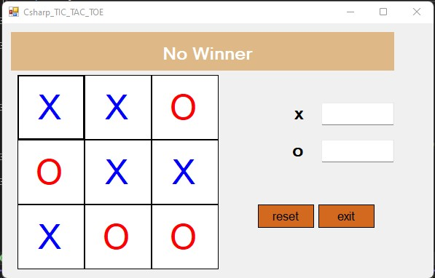

**Question # 03:**

3.Create Rock Paper scissor game.

